AKALLA TORGET · CONCEPT DEMO
Demo test guide
How to try the website, ordering and the staff panel – role by role

Demo access
What | Address
Website (guests) | https://akallatorget.hubgreen.se/en/
Staff panel (all staff roles) | https://akallatorget.hubgreen.se/admin/
Table ordering (as if you scanned the QR code on table 5) | https://akallatorget.hubgreen.se/en/table/5/

Demo logins: the usernames and passwords for the five demo roles (owner, manager, floor manager, kitchen and guest member) are sent to you separately by HubGreen.
Ask your HubGreen contact if you have not received them.

Please note – this is a demo
- Payments are simulated: no money is charged. Never enter real card details.
- Orders only reach the demo's own kitchen screen – nobody cooks them.
- Menu, prices, dishes and images are examples, not your real menu. Allergen information is not filled in.
- It is not a certified cash register and does not replace your current till system.

Version: 19 October 2026 · Concept demo by HubGreen

1. Before you start
The demo has two sides: the website that guests use (menu, ordering, table booking, membership) and the staff panel where the kitchen, floor staff and managers work. Everything updates live – an order placed on a phone appears on the staff screens within a second or two.

What you need
- A phone (for the guest side) and a computer or tablet (for the staff side). Testing with two devices side by side shows best how it works.
- The demo logins (see the first page).
- About 30–45 minutes for the test scenarios in chapter 7.

Language and appearance
- Website: press SV / EN at the top to switch between Swedish and English.
- Staff panel: press EN (or SV) at the top right.
- The sun/moon button switches between light and dark mode on both sides.

Logging in
- Staff: open https://akallatorget.hubgreen.se/admin/, enter the email and password for the role you want to test and press Log in.
- Guest member: on the website press Log in at the top (or go to My account) and log in with the guest account – or press Join and create your own membership with your own email address.
- To test another role, use Log out (bottom of the staff menu) and log in again – or use a second browser / a private window so two roles are open at the same time.
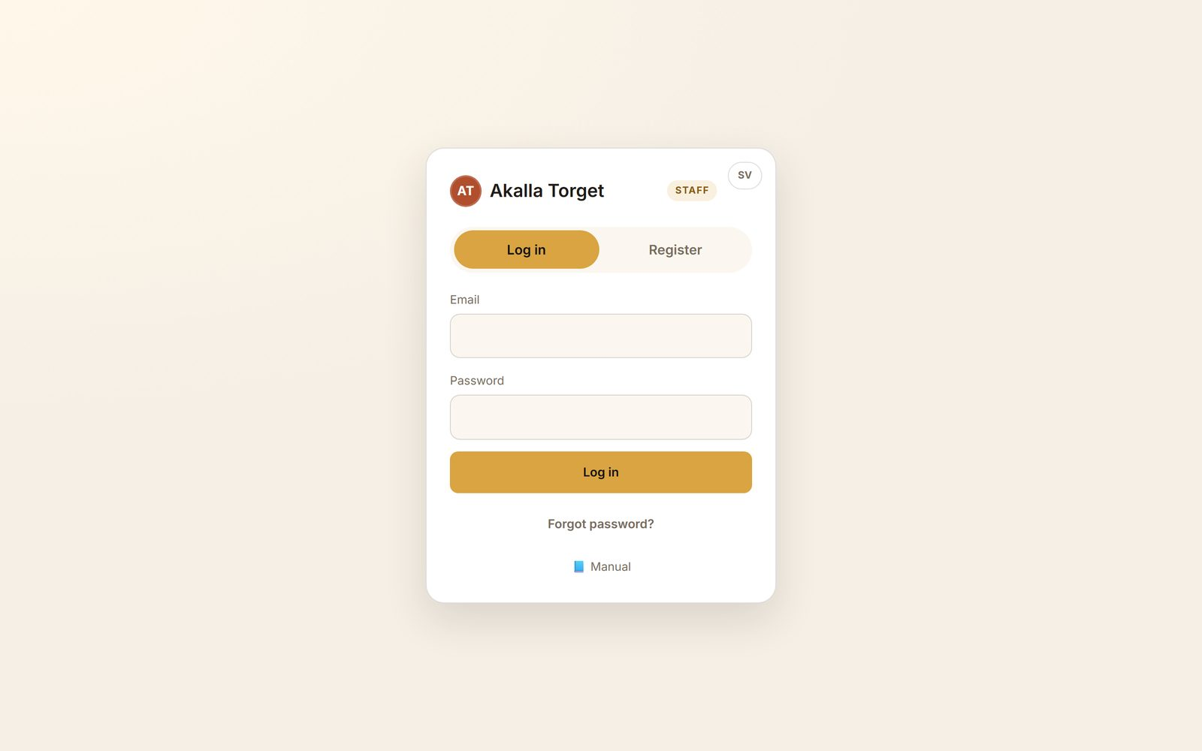
The staff panel login
Tip: each role only sees its own pages. The kitchen sees Kitchen and Availability; the floor manager sees the service pages; managers and the owner see everything.  Sound: tap the bell-with-a-line icon at the top right of the staff panel and switch sound on, so the device plays a sound for new orders. | 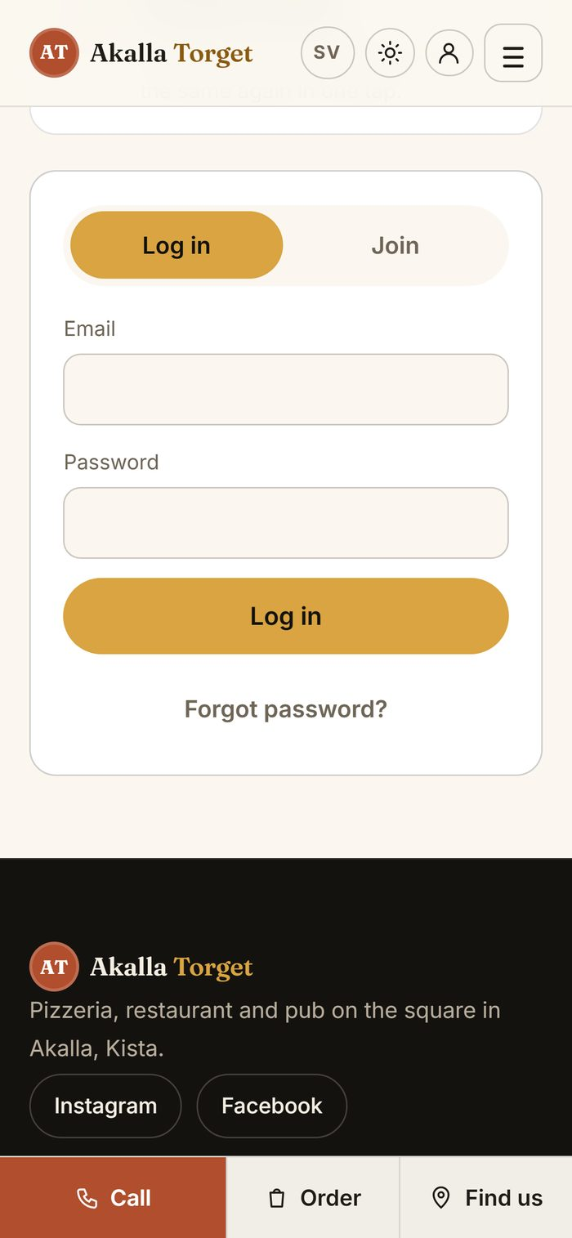  Member login on the website

Opening hours in the demo
Online ordering follows the demo's opening hours (currently 12:00–23:00). Outside them guests can still choose a pick-up time later in the day.

2. The roles at a glance
Role | What to test | Main pages
Guest | Browse the menu, order for pick-up or at the table, book a table, become a member | Website
Kitchen | Receive tickets, set prep time, mark ready, mark a dish as sold out | Kitchen, Availability
Floor manager | Follow the service, take orders at the counter, handle bookings and payments | Overview, Orders, New order, Table bookings, History
Manager | Change dishes, prices and specials, look at analytics, members and email | Dishes, Prices, Specials, Analytics, Customers, Email & campaigns, Hours & routines
Owner | Everything a manager can, plus team, approvals and the activity log | Team, Recycle bin, Activity log

Please, while testing: do not remove staff accounts, change the invite code, change the demo passwords or send email campaigns to the member list – other people use the same demo.

3. Guest – the website

3.1 Home page and menu
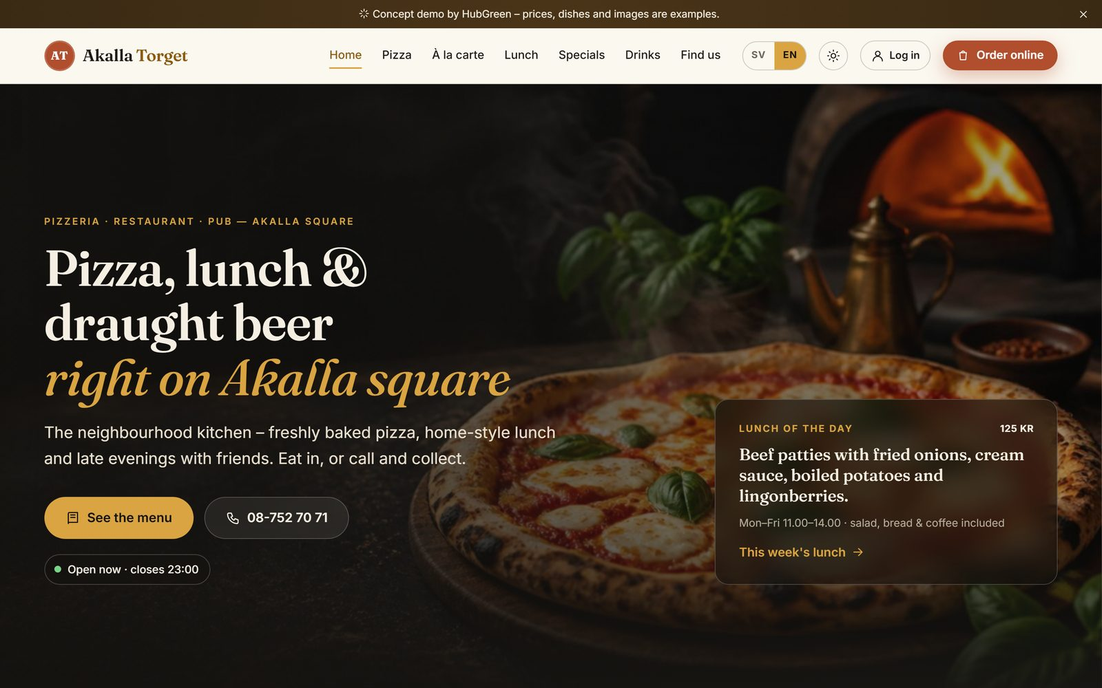
Home page: menu, lunch of the day, opening hours and "Order online"
- Open the website and look around: Pizza, À la carte, Lunch, Specials, Drinks and Find us.
- On a menu page, use the search field and the filters Vegetarian and Spicy.
- Tap Allergies and choose an allergen (for example Tree nuts). Dishes whose allergens are not filled in yet show "Ask our staff".
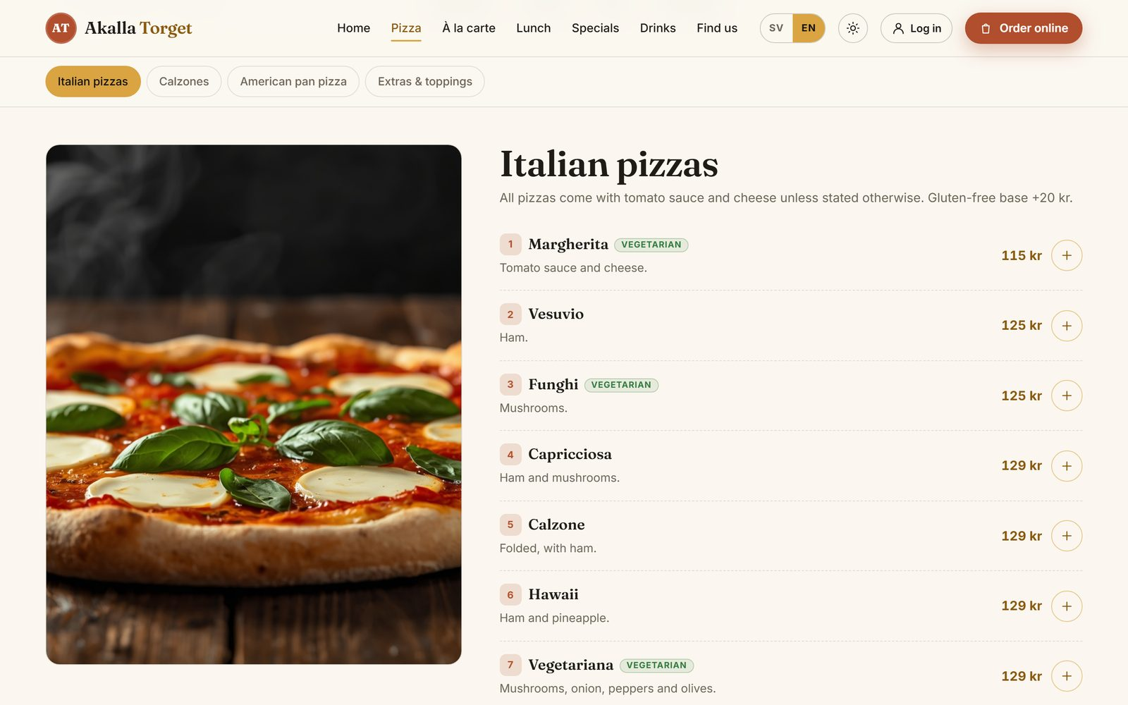
A menu page with categories and labels
Allergy filter  Choose what to avoid and dishes containing it disappear. In the demo no allergen information has been entered yet, so every dish says "Allergens not declared – ask our staff". The real information must come from the restaurant. | 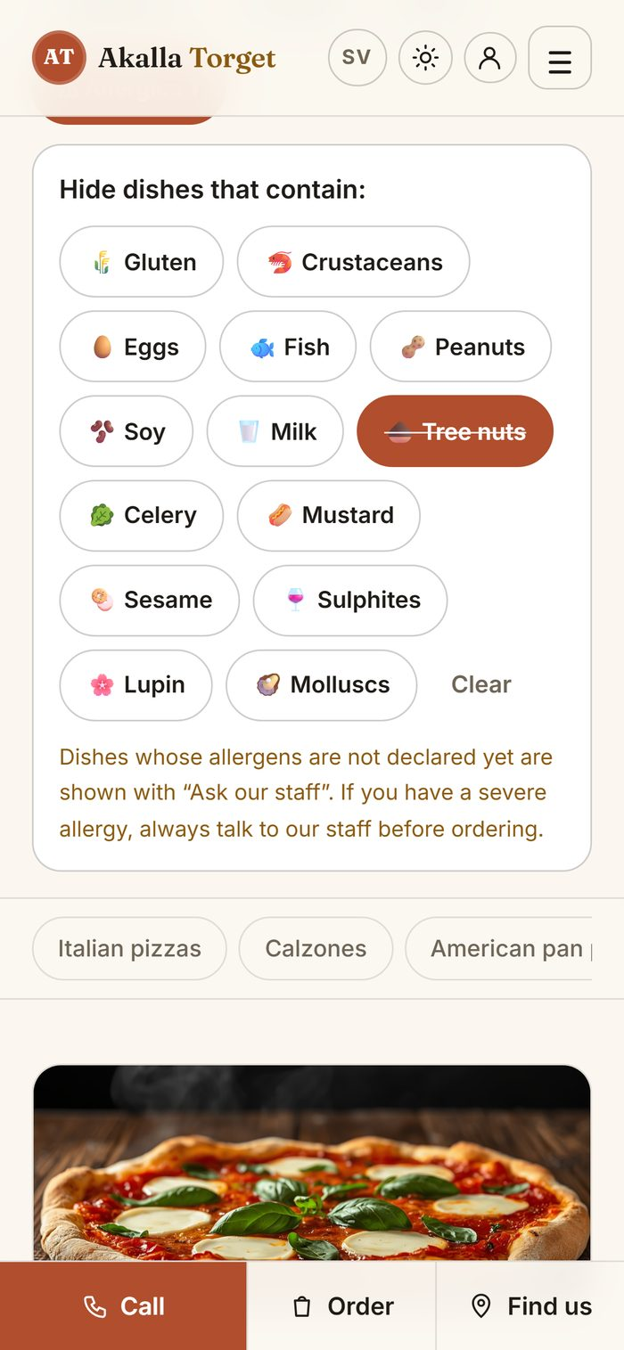  Allergy filter on a phone

3.2 Order for pick-up
- Press Order online and choose Pick-up.
- Tap + on a dish. You can make it a meal (small, medium or large) and add or remove extras. Press Add to order.
- Open the basket at the bottom (Your order) and press Go to payment.
- Enter a name and a mobile number (any number works in the demo), choose a pick-up time and a payment method, and pay. The payment is simulated – no money is charged.
- You now see your order live: Paid → Preparing → Ready to collect → Collected, with the expected time.
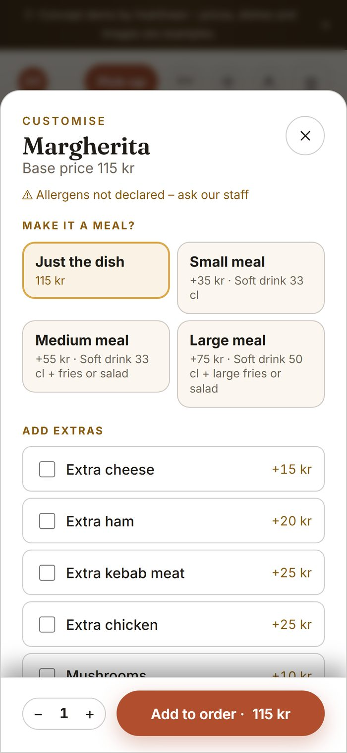  Choose a meal and extras | 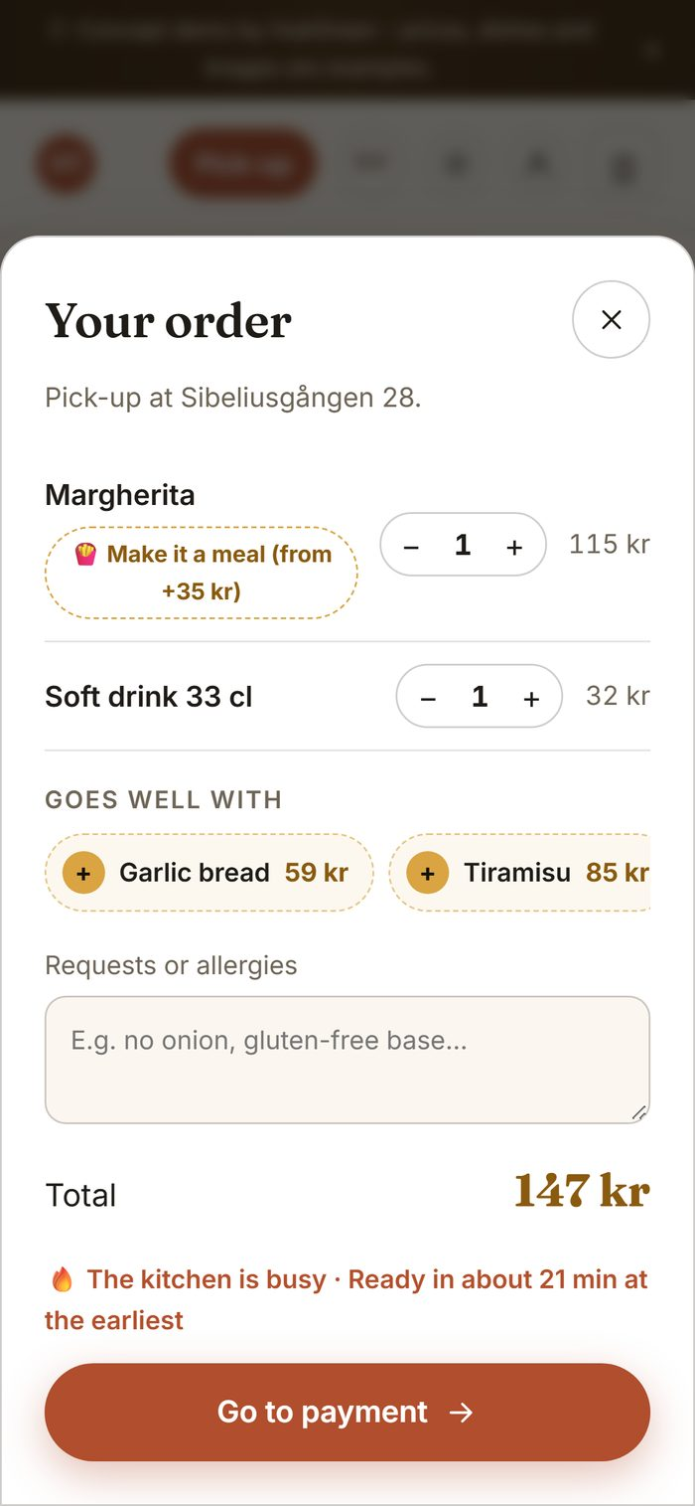  Your order | 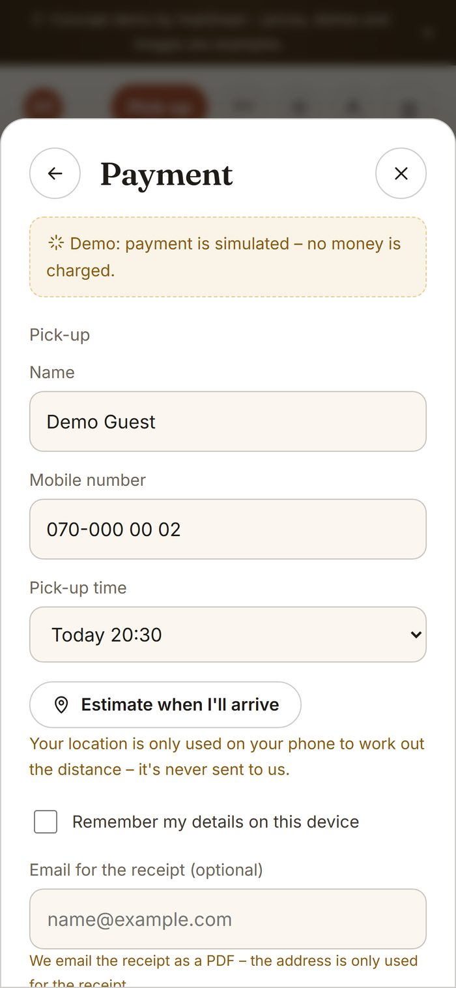  Payment (simulated)

Following the order  The page updates by itself as the kitchen works. Keep it open and switch to the staff side (chapters 4 and 5) to move the order along.  The order page also shows how busy the kitchen is right now, for example "The kitchen is busy – food in about 20 min". | 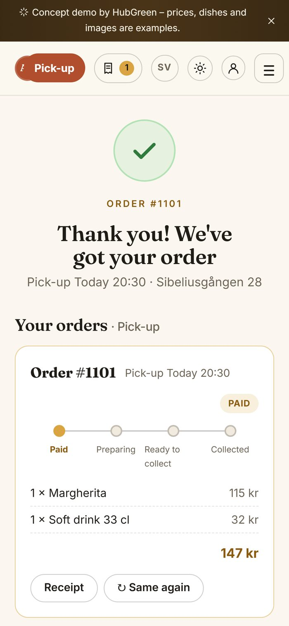  Order status after paying

3.3 Order at the table
- Open https://akallatorget.hubgreen.se/en/table/5/ – this is what a guest gets when scanning the QR code on table 5.  - Order and pay on the phone, just like for pick-up. The order is marked "Table 5" for the staff.  - Tap the bell at the top to call staff (water, cutlery or staff). It appears at once in the staff panel.  - When the order is marked as served, the guest is asked "How was your food?" and can give 1–5 stars. | 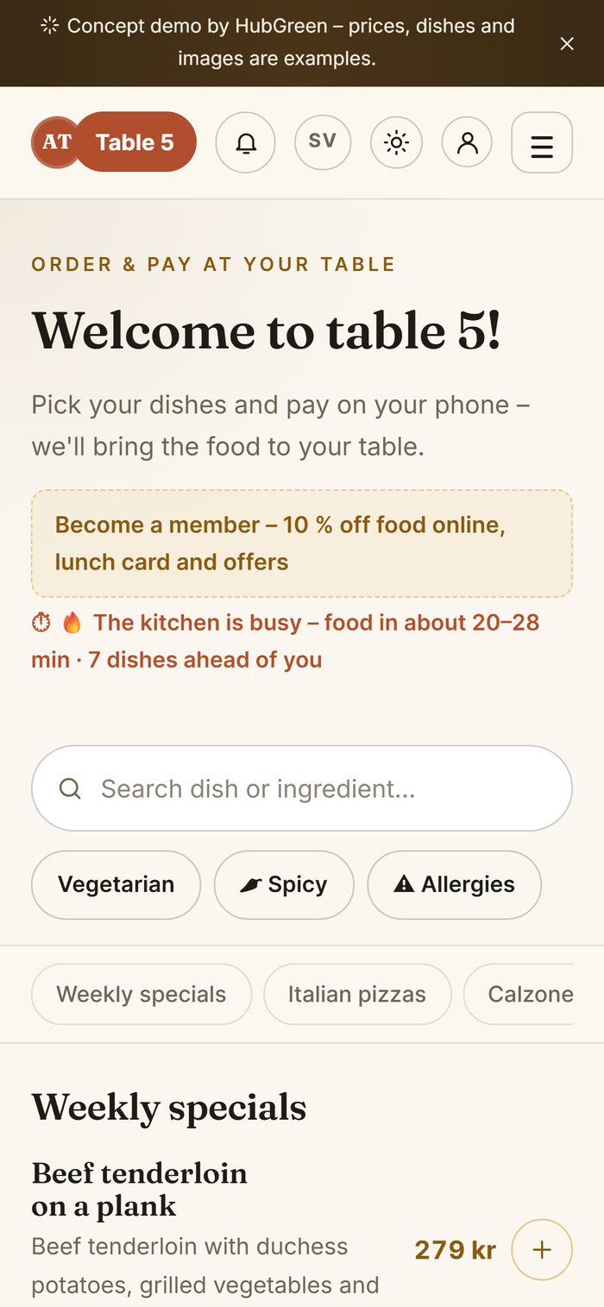  Ordering at table 5

3.4 Book a table
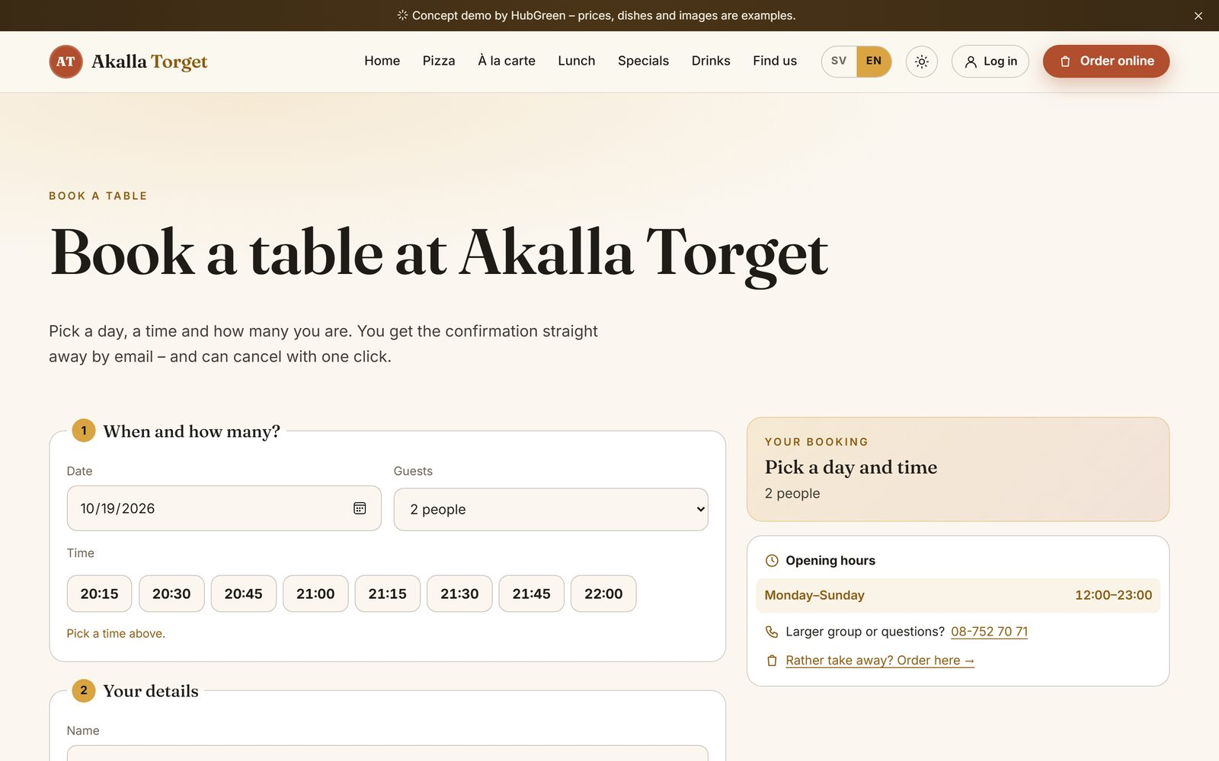
Book a table: day, number of guests and time
- Press Order online → Book a table (or go to Book a table in the menu).
- Choose a day, the number of guests and a time, then enter your name and phone number.
- Use your own email address if you want to receive the confirmation email (with a cancel link).
- Depending on the settings the booking is confirmed straight away or waits for the staff to confirm it (chapter 5).

3.5 Membership
- Log in as the demo guest member (or join with your own email).
- My account shows the member number, the member discount, the lunch card, offers and every order with its receipt.
- Press Show member code: a QR code and four digits that change every few minutes. Staff scan it or type the digits at the till (chapter 5).
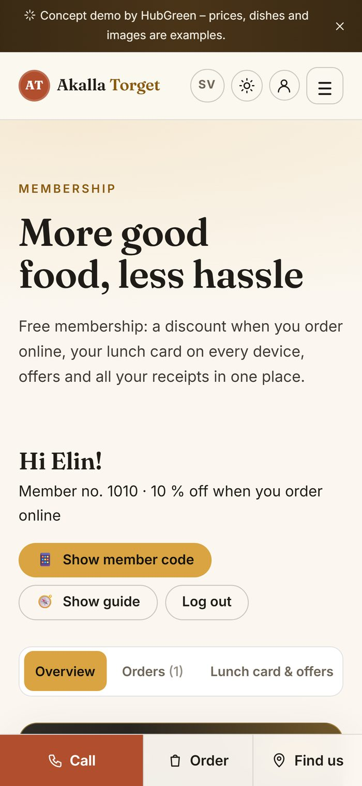  My account | 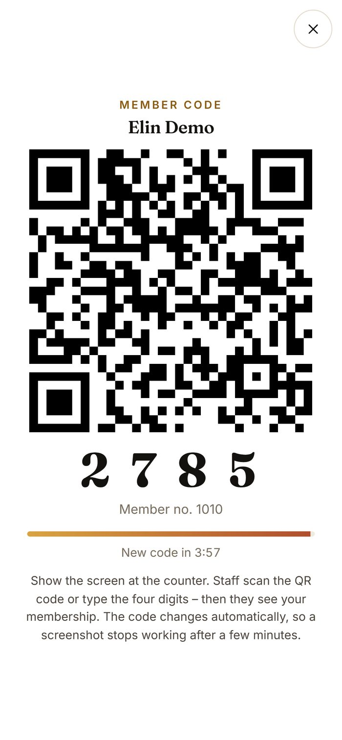  Member code for the till

4. Kitchen
Log in with the kitchen account. The kitchen only sees Kitchen and Availability.
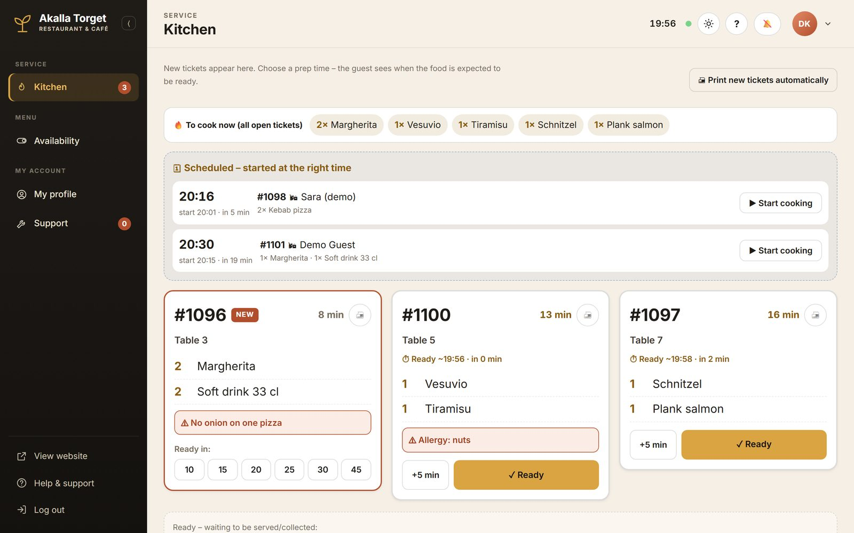
The kitchen display

Cooking an order
- New tickets are marked NEW. Tap how many minutes the food will take (10–45). The guest then sees when the food is expected.
- Notes and allergies are highlighted in red on the ticket. The bar at the top (To cook now) adds up every open ticket.
- Need more time? Press +5 min.
- When the food is ready, press Ready. The floor manager is notified and the guest's page changes to "Ready".
Scheduled orders: pick-ups ordered for later wait in their own list and move to the tickets at the right time. Start cooking starts one early.

A dish has run out
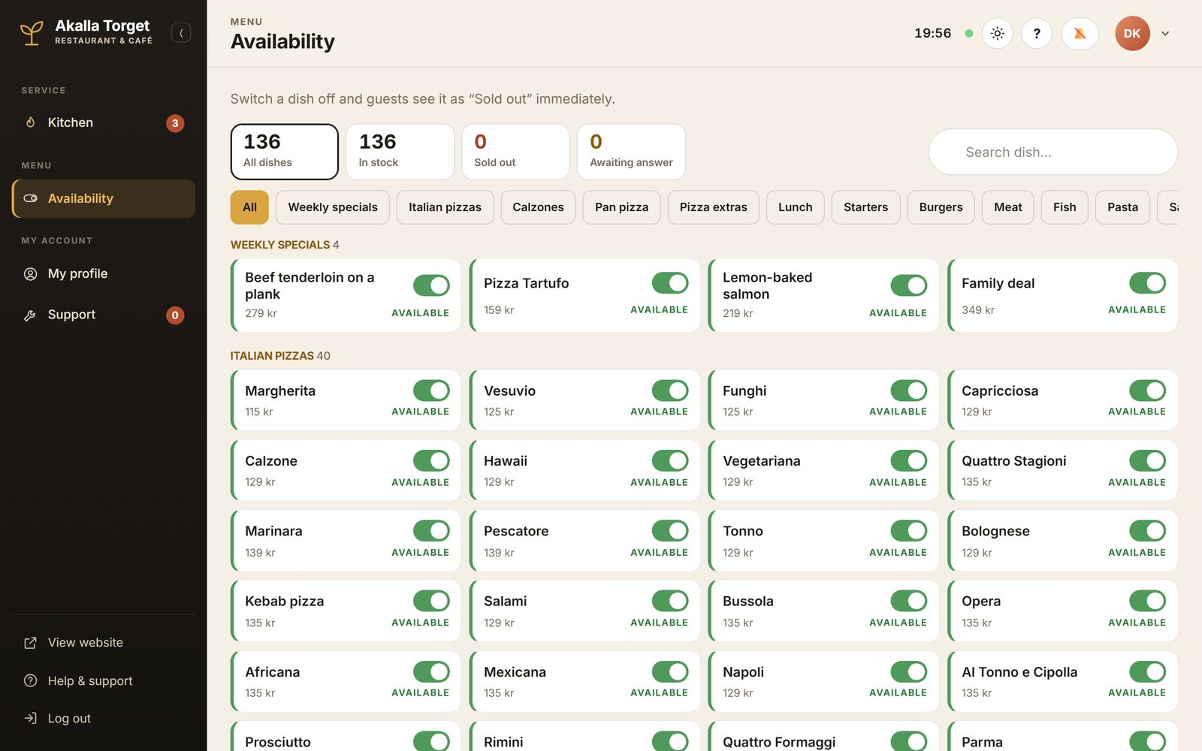
Availability: switch a dish off when it runs out
- Open Availability, find the dish and switch it off. You can write a reason ("out of mozzarella").
- The floor manager gets a request and approves it.
- The dish is then shown as "Sold out" on the website and in ordering. Switch it on again the same way.

5. Floor manager
Log in with the floor manager account. The floor manager runs the service: overview, orders, the till, bookings and history.

5.1 Overview
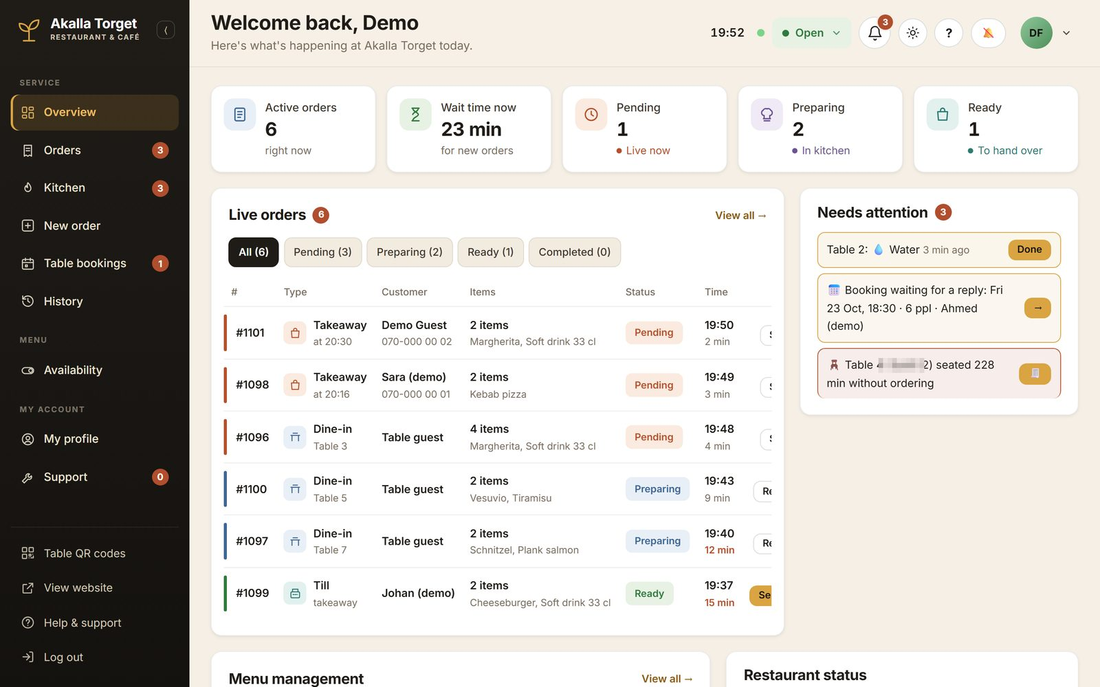
The floor manager's start page (one guest name blurred)
- Live orders: every order with type, status and waiting time.
- Wait time now: how long a new order will take, based on the dishes in the kitchen queue.
- Needs attention: a table calling for staff, a booking waiting for a reply, guests seated a while without ordering, orders served but not paid.

5.2 Orders
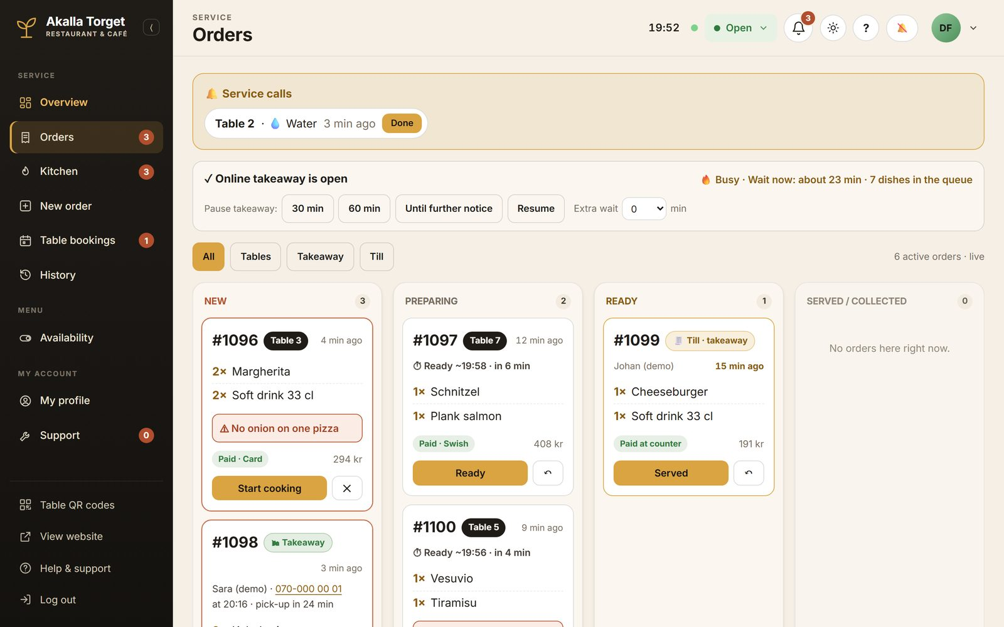
The order board
- New orders appear under New with a sound. Press Start cooking (or let the kitchen choose the time).
- When the kitchen presses Ready, the order moves to Ready. Press Served / Collected when the guest has the food.
- Service calls from tables appear at the top – press Done when handled.
- When it gets busy: Pause takeaway (30/60 min or until further notice) or add Extra wait. Guests see it immediately.
On a phone  The same board works on a phone: the main pages are at the bottom and the rest under More. Handy for staff on the floor. | 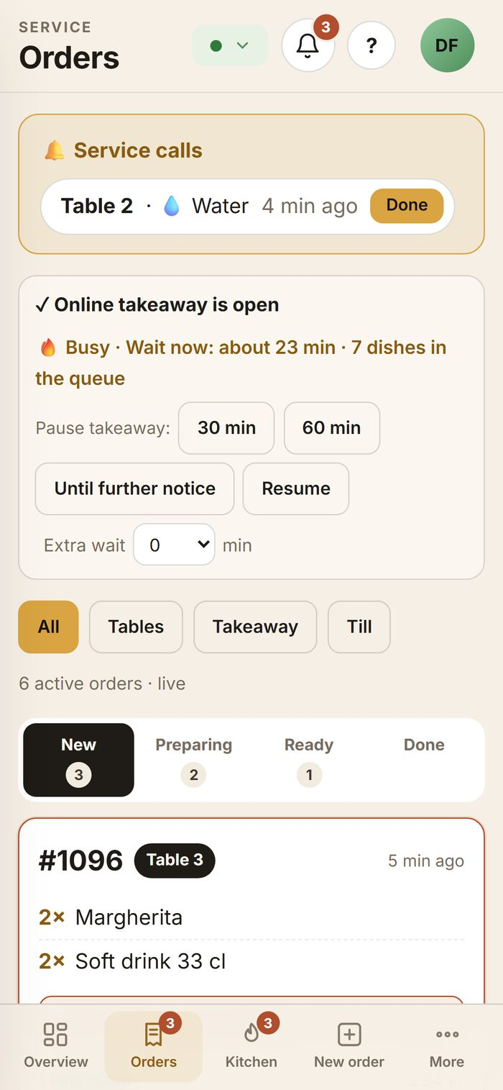  Orders on a phone

5.3 New order (the till)
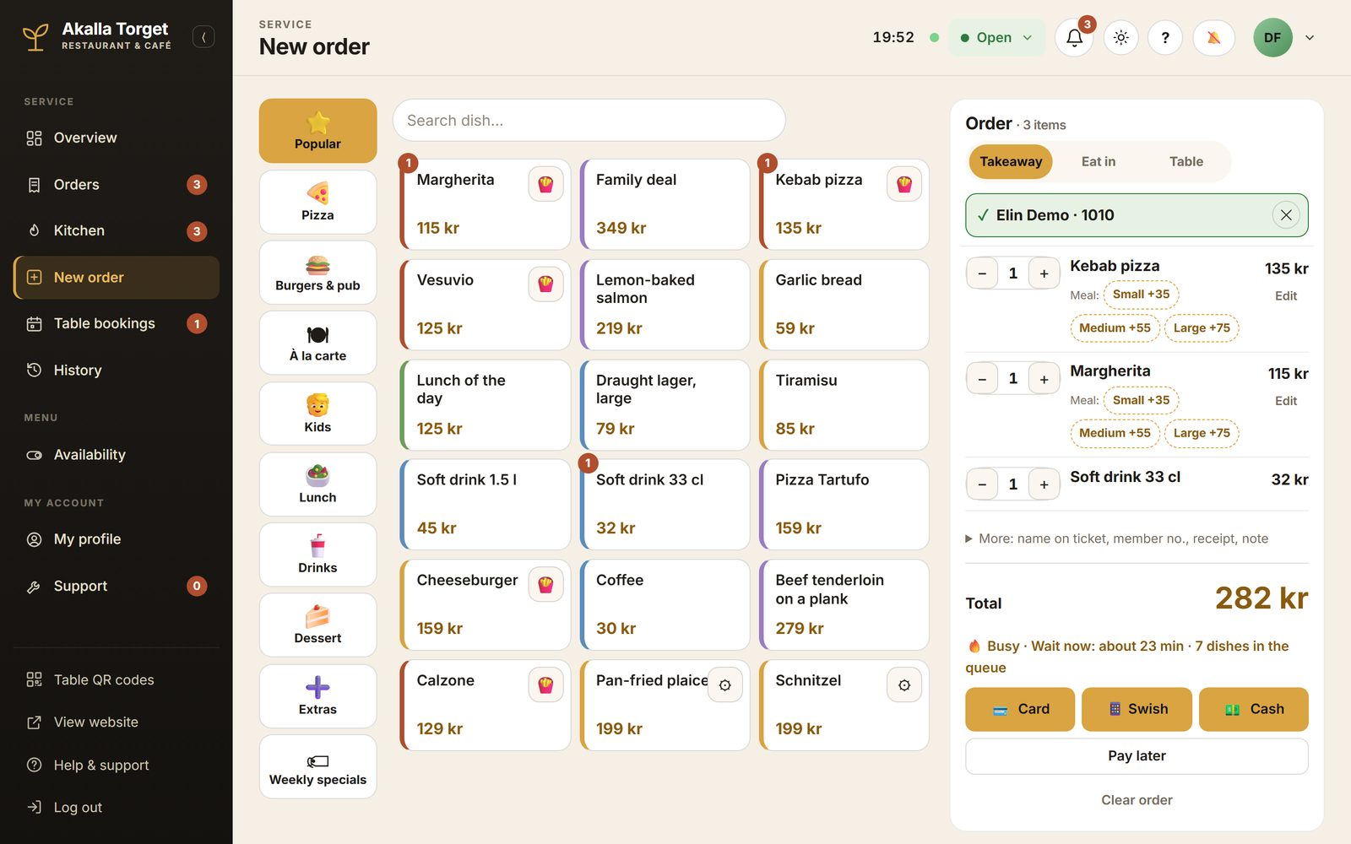
New order at the counter
- Tap the dishes. Popular shows what sells most; the category buttons on the left show the rest. The meal buttons (Small/Medium/Large) turn a dish into a meal.
- Choose Takeaway, Eat in or Table (and the table number).
- Member? Scan the member code from the guest's phone or type the four digits / the member number. The member's name appears on the order.
- Press Card, Swish or Cash to record how the guest paid – or Pay later to keep an open bill. The order goes to the kitchen at once.
Good to know: the payment buttons only record the payment method. No card terminal or Swish is connected, and this is not a certified cash register.

5.4 Table bookings
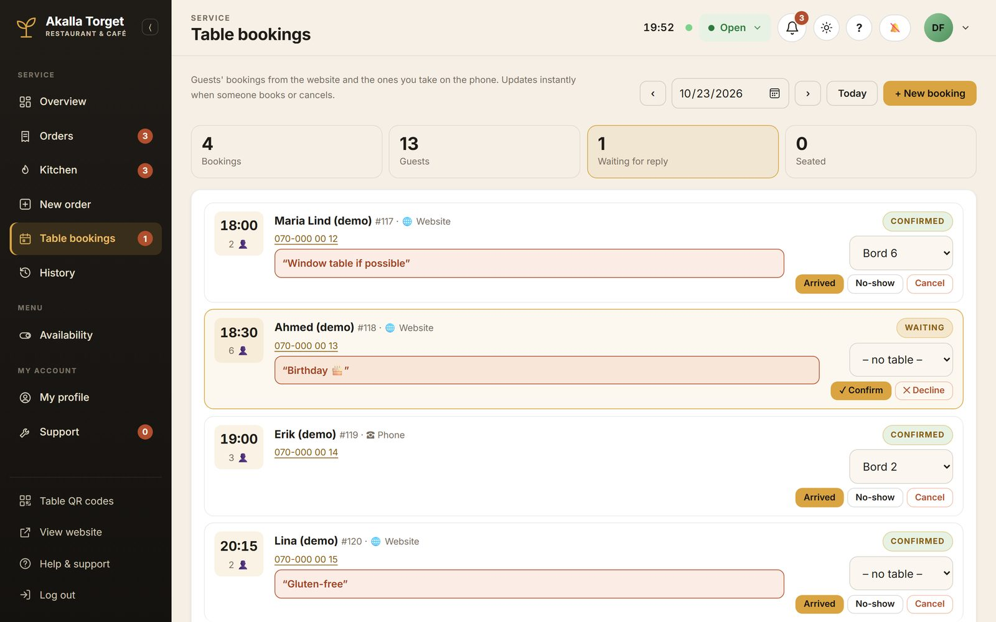
Table bookings for a chosen day (sample bookings)
- Bookings from the website appear here at once. Confirm or Decline a request – the guest gets an email.
- Choose a table for the booking.
- When the guests arrive, press Arrived – the table is shown as seated on the overview. No-show and Cancel are also here.
- Phone bookings: press + New booking.

5.5 History
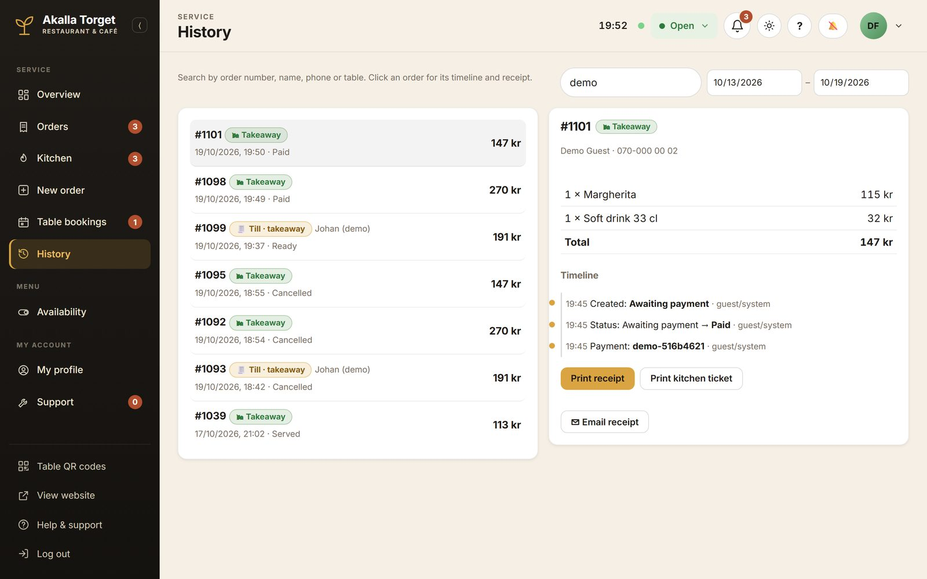
History: search, timeline and receipt
Search by order number, name, phone or table. Click an order to see its timeline, print a receipt copy or a kitchen ticket, or email the receipt.

5.6 Approving "sold out"
When the kitchen switches a dish off, a request appears (Availability → Awaiting answer, and in the bell at the top). Approve it and the dish is shown as sold out to guests.

6. Manager and owner
Log in with the manager account. A manager sees everything the floor manager sees, plus the menu and business pages.

6.1 Overview and analytics
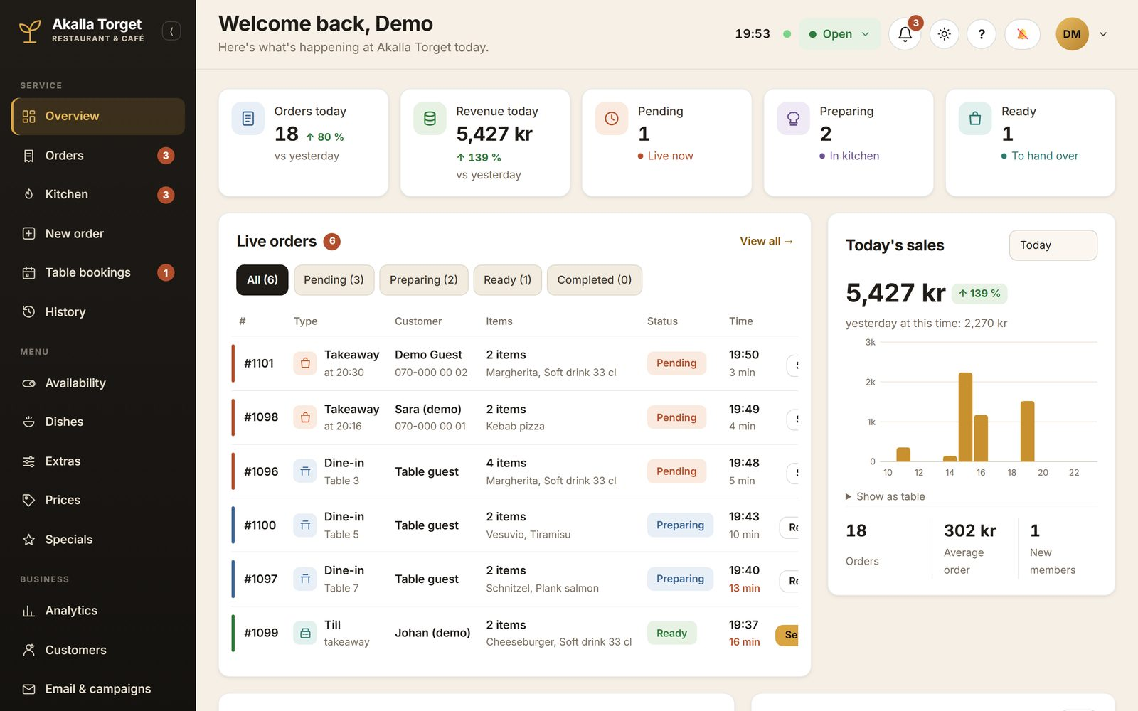
The manager's overview with today's sales (test data)
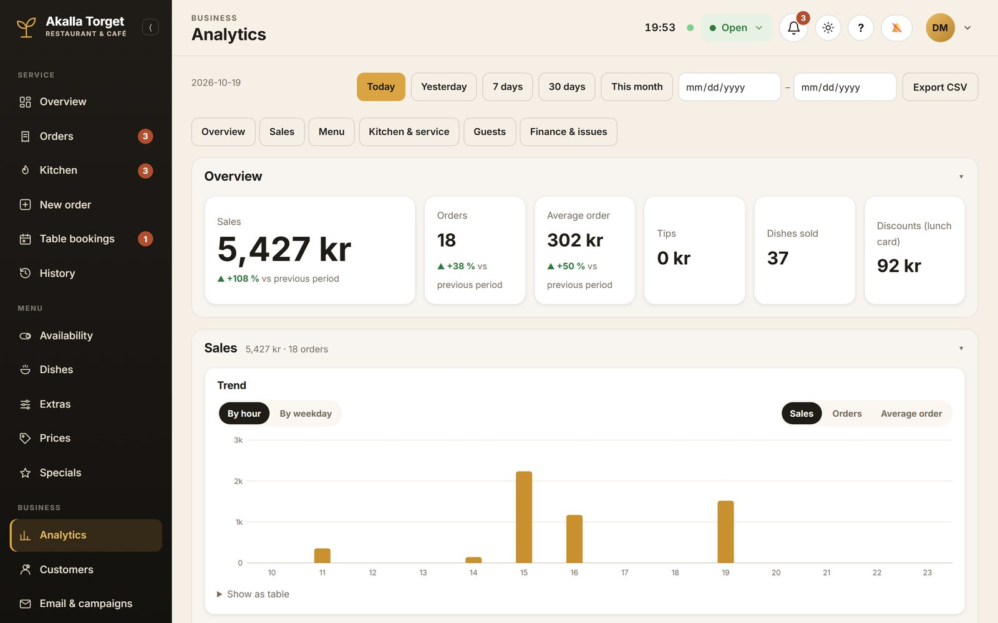
Analytics: choose a period, export to CSV
Choose a period (today, yesterday, 7 days, 30 days, this month or your own dates) and look at sales, the menu, kitchen times and guests. All figures in the demo come from test orders.

6.2 Dishes
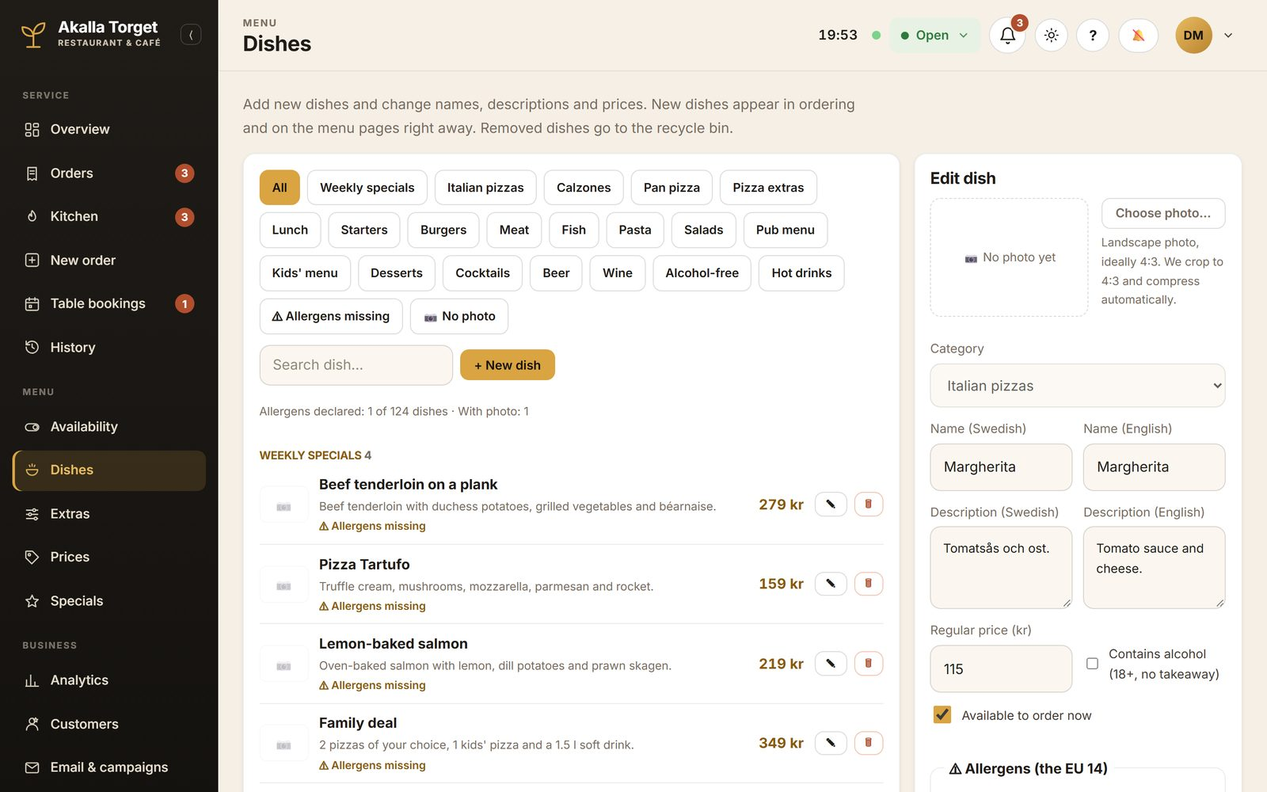
Dishes: edit a dish
- Open Dishes and press the pencil on a dish (or + New dish).
- Change the name, description or price. You can add a photo (it is cropped and compressed automatically).
- Allergens: tick the EU's 14 allergens the dish contains and tick The allergens of this dish are checked. Suggest from name and description ticks likely allergens for you to check.
- Labels: vegetarian, vegan, gluten-free, lactose-free, spicy, popular.
- Save – the change shows on the website and in ordering straight away.
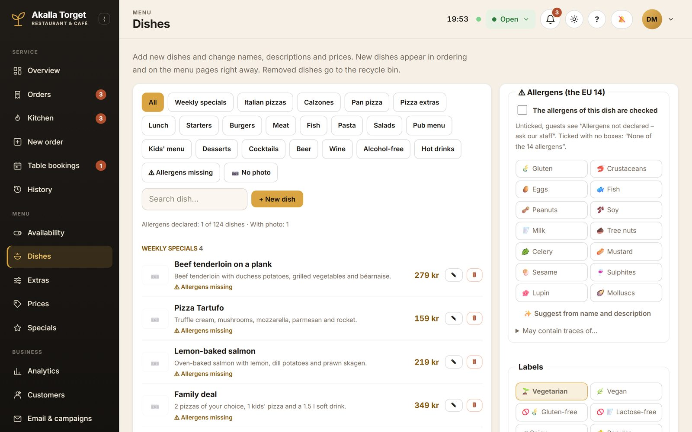
Allergens and labels in the dish editor

6.3 Prices, extras and specials
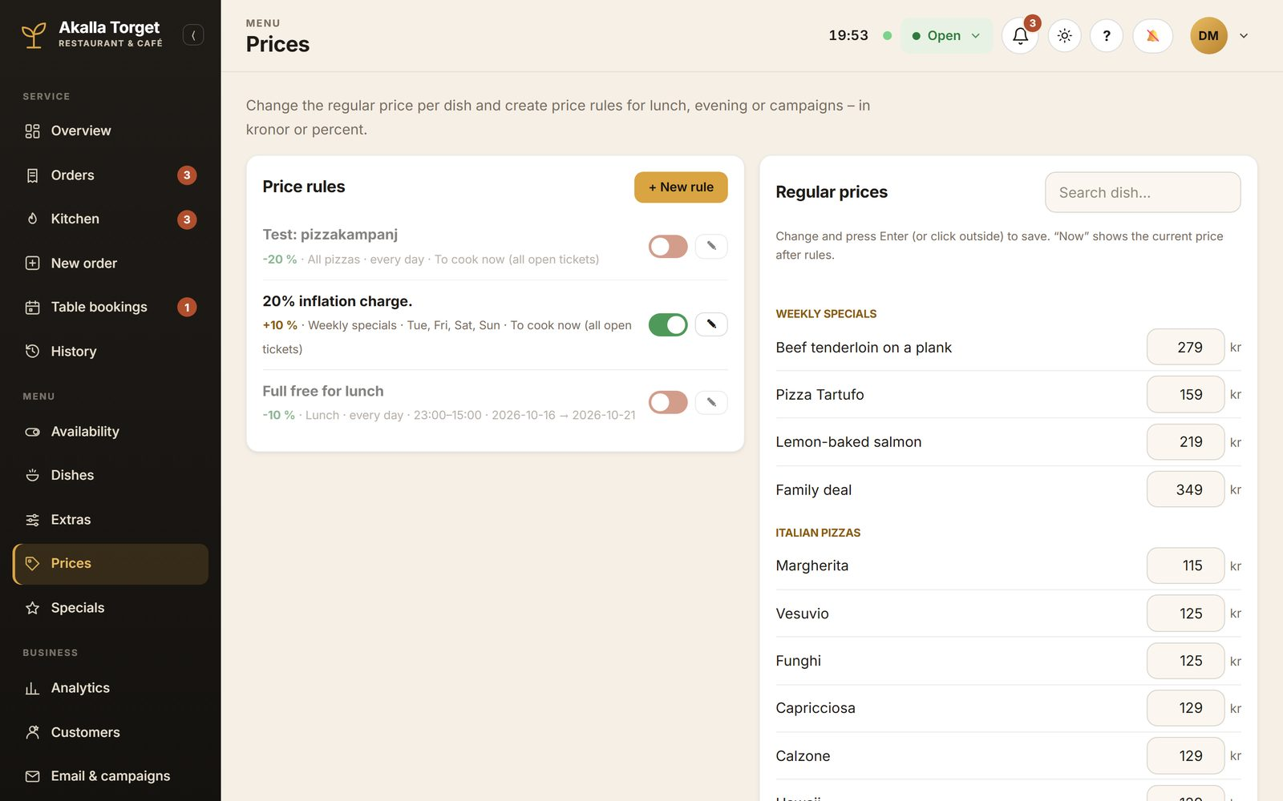
Prices and price rules
- Prices: change a regular price in the list and press Enter. Price rules change prices for a period, certain days or times (lunch price, happy hour, campaign).
- Extras: what guests can add (extra cheese +15 kr) or remove (no onion).
- Specials: today's special as a pop-up on the home page, optionally linked to a dish so guests can order it directly.

6.4 Reviews and the thank-you discount
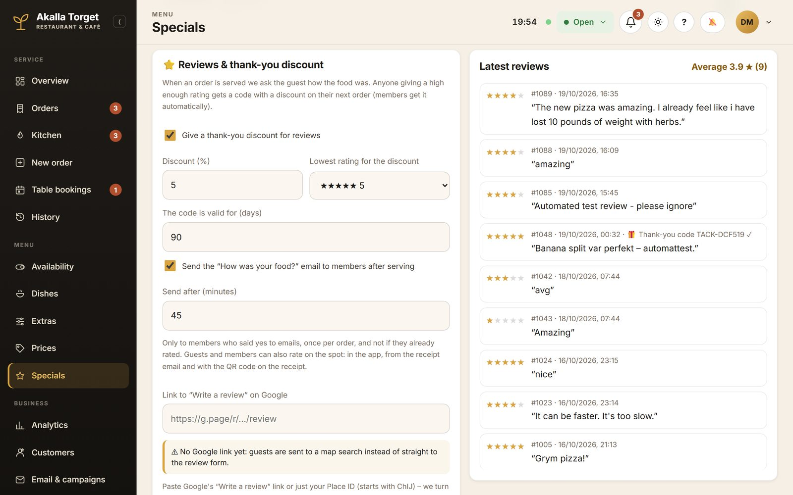
Specials page: reviews and the thank-you discount
Set whether guests who leave a review get a discount code for next time, the "How was your food?" email, and the link to your Google review page. On the right you see the latest reviews.

6.5 Opening hours, customers and email
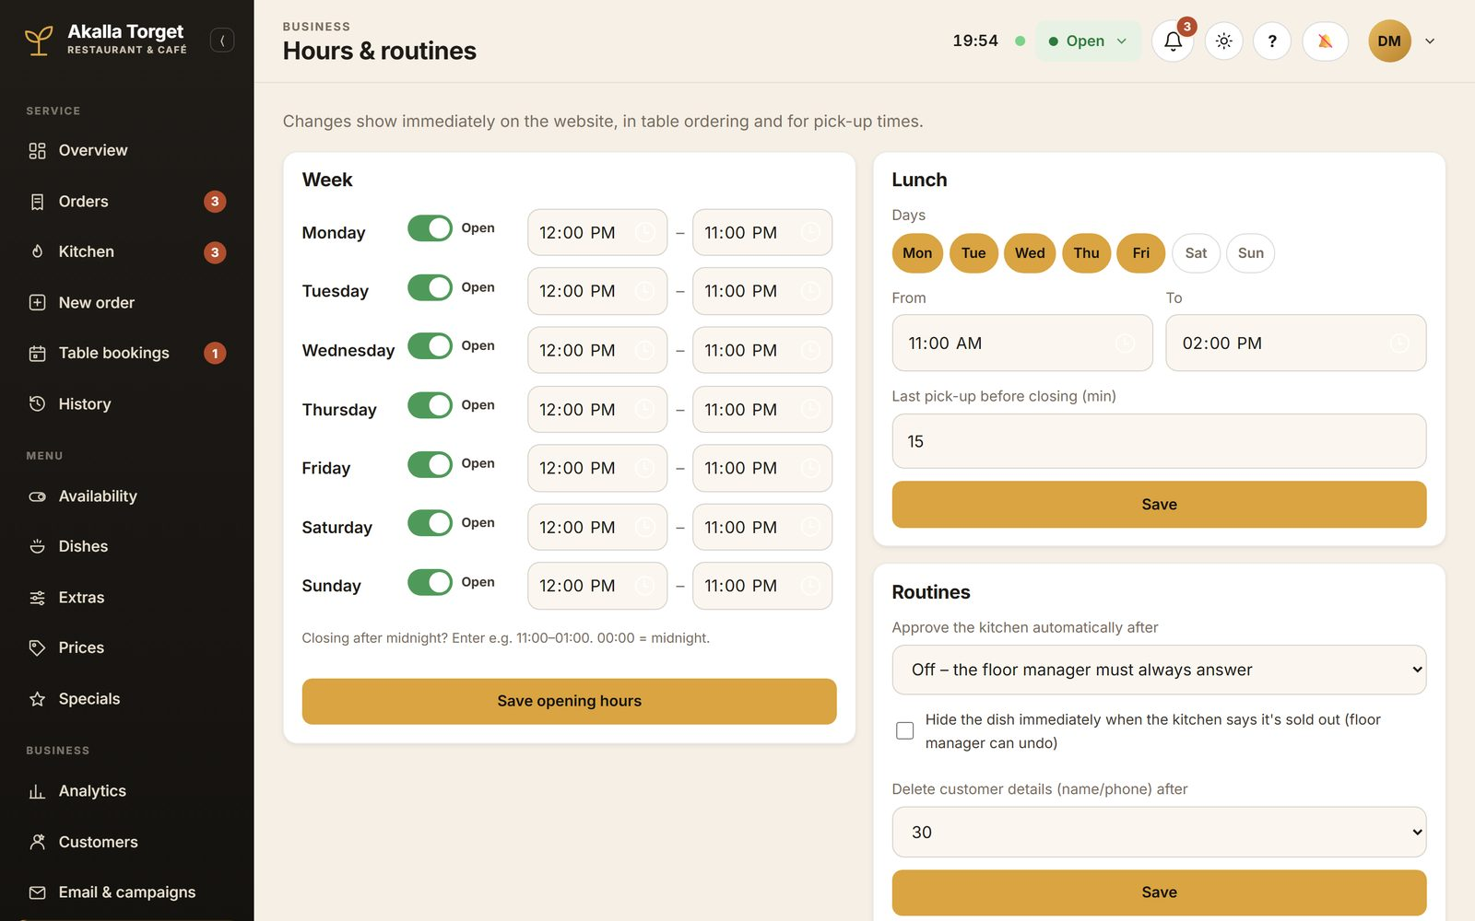
Hours & routines
- Hours & routines: opening hours per day, lunch hours, special days, and whether the kitchen's sold-out requests are approved automatically.
- Customers: members, their consents and the member discount. Exports only include people who said yes to offers.
- Email & campaigns: news, events and offers to members, the email templates and the send log. Please do not send campaigns in the demo – use the preview instead.
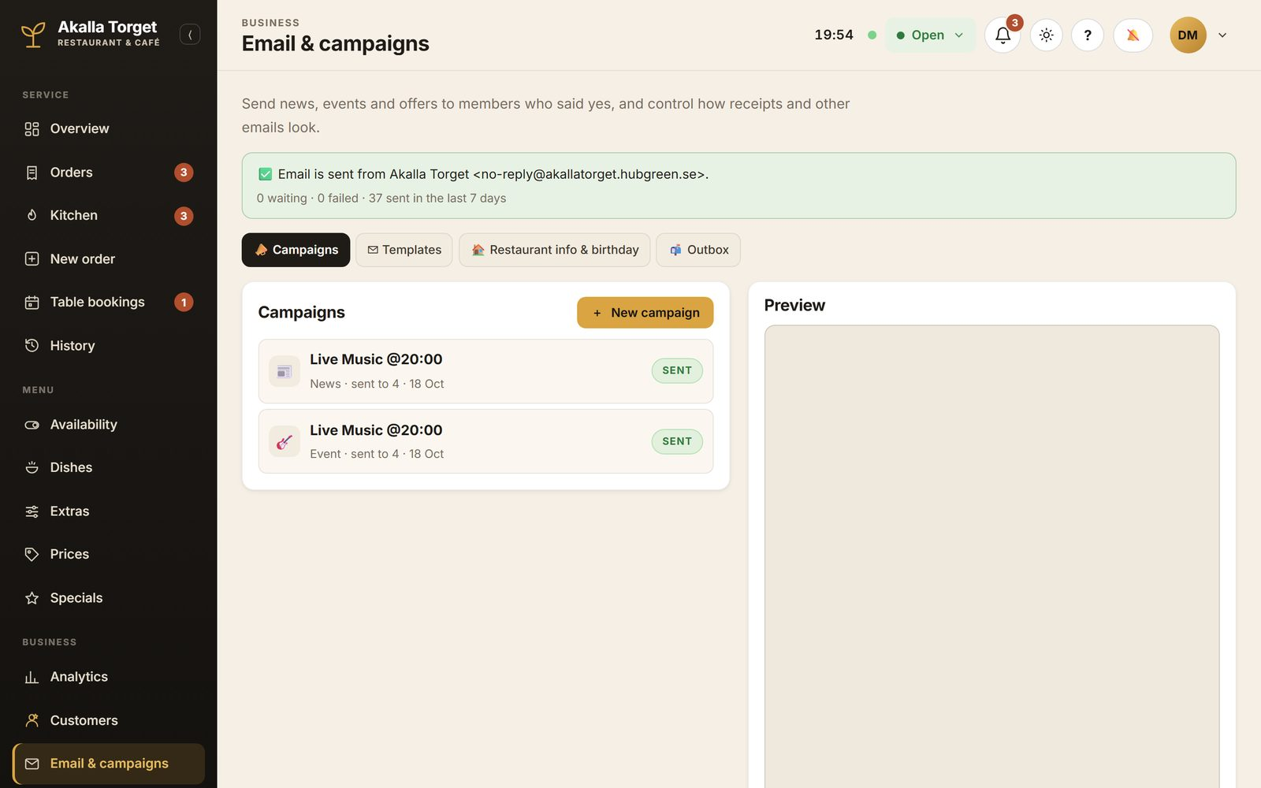
Email & campaigns

6.6 Only for the owner
Log in with the owner account to see the extra controls.
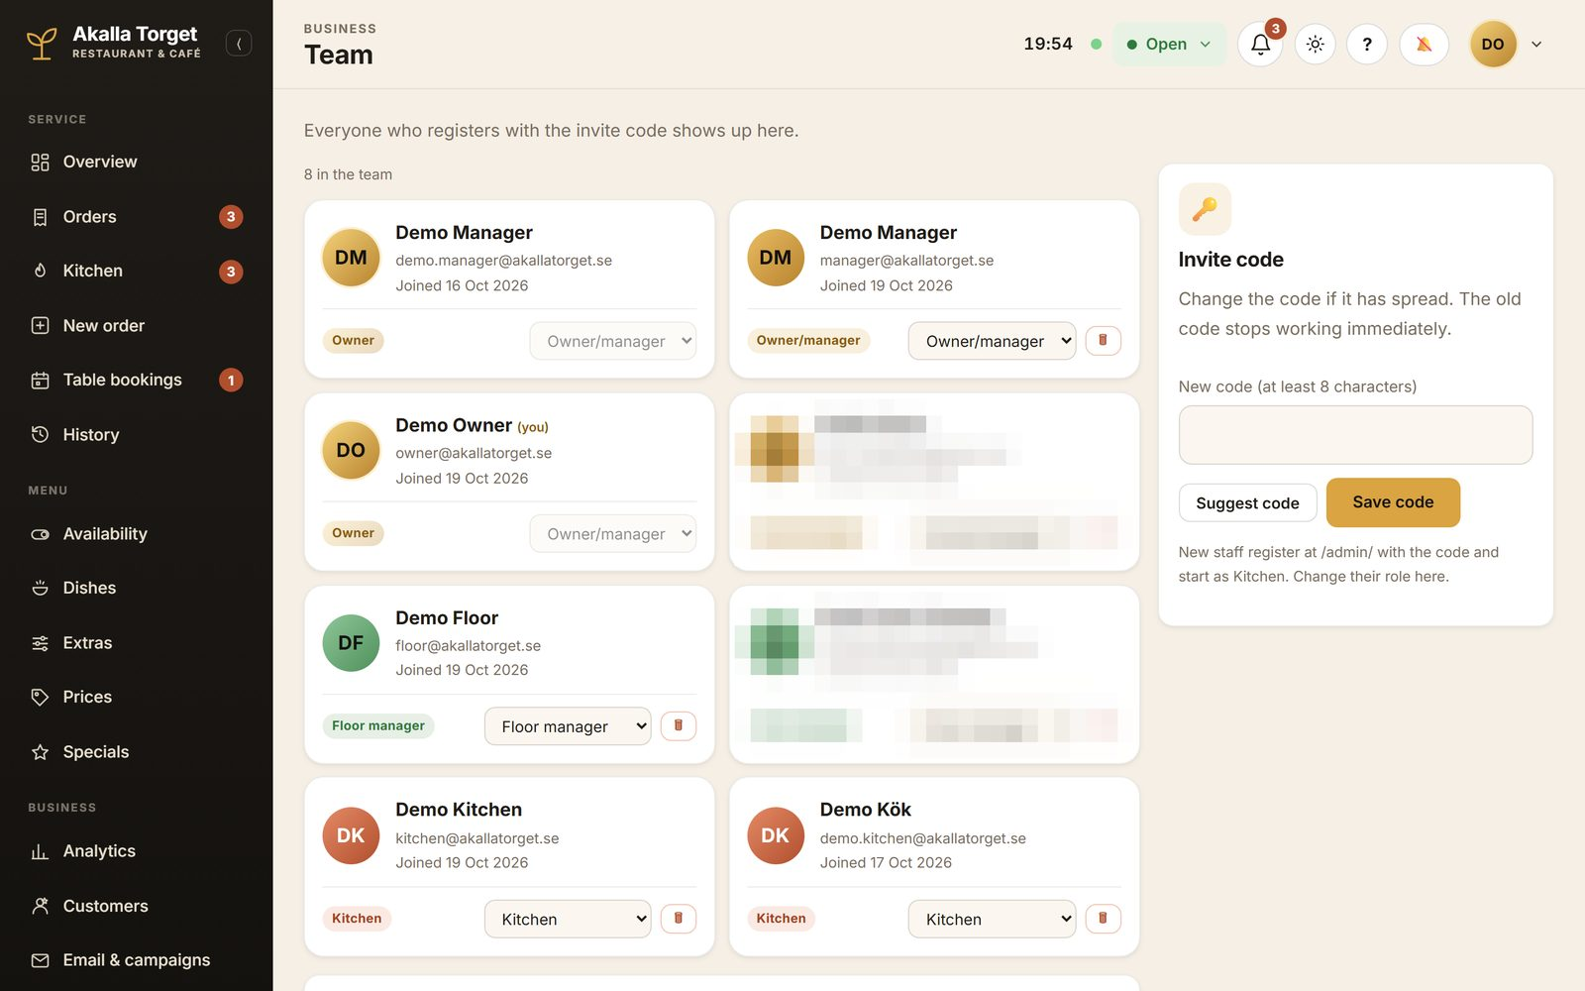
Team (two real staff accounts blurred)
- Team: everyone who registered with the invite code. Only the owner can make someone a manager. (Please do not change roles or remove anyone in the demo.)
- Recycle bin: nothing is deleted on the spot. Removed dishes, rules or people wait here until the owner approves – or restores them.
- Activity log: every change and sign-in, with who did it and when. Can be filtered and exported.
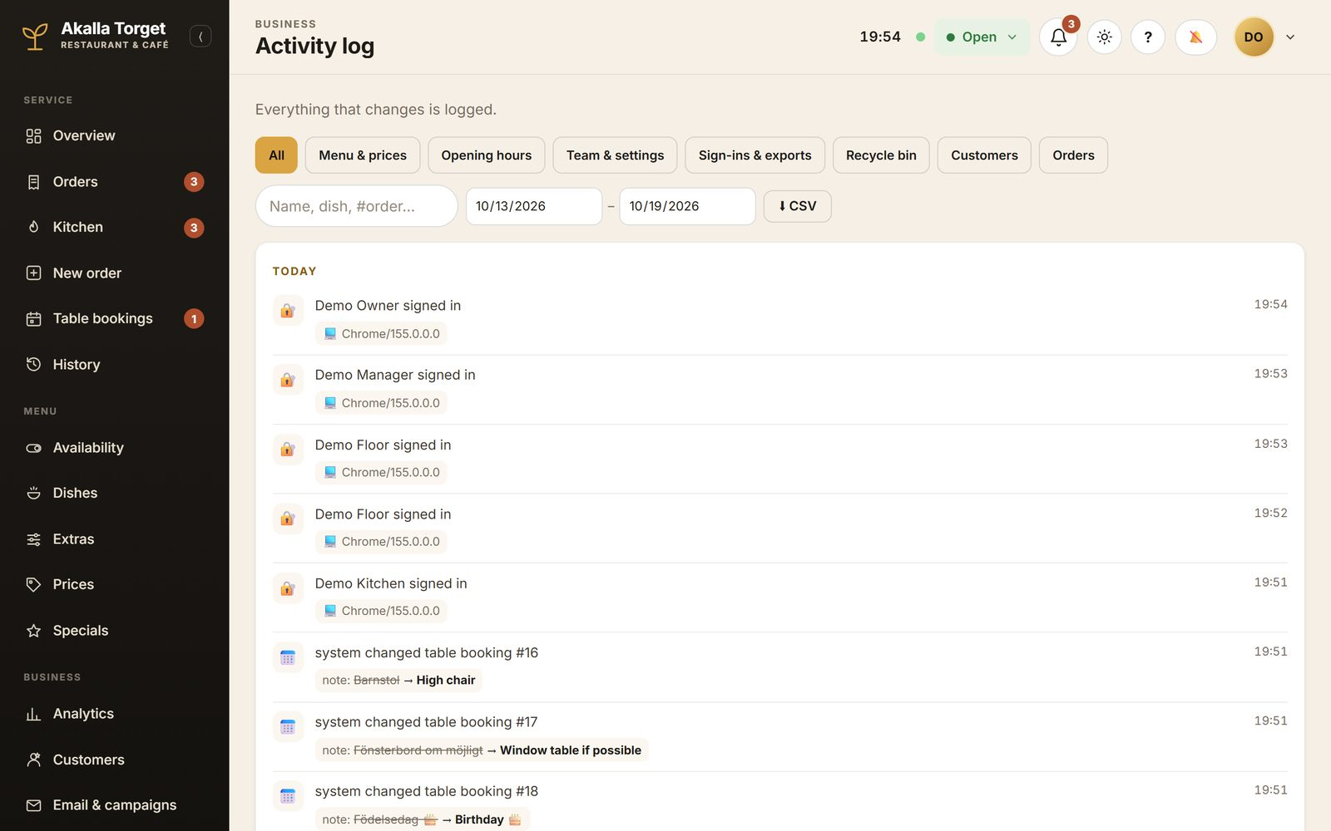
Activity log

7. Test scenarios
Tick each step as you go. Use two devices (or two browser windows) so you can see both sides at once. Write anything unexpected in the feedback table in chapter 8.

A. A pick-up order from start to finish (Guest + Kitchen + Floor manager)
☐ Guest: order a pizza as a meal for pick-up and pay (simulated).
☐ Floor manager: the order appears under New on Orders, with a sound.
☐ Kitchen: the ticket appears – choose 15 minutes. The guest's page shows the expected time.
☐ Kitchen: press Ready. The guest's page changes to "Ready to collect".
☐ Floor manager: press Collected. The guest's page changes to "Collected".

B. Order at the table and call staff (Guest + Floor manager)
☐ Guest: open the table-5 link, order a drink and pay.
☐ Guest: tap the bell and choose Water.
☐ Floor manager: the call shows on Orders and the Overview – press Done.
☐ Move the order to Served. Guest: the "How was your food?" question appears – give stars and a comment.
☐ Manager: the review appears under Specials → Latest reviews.

C. A dish runs out (Kitchen + Floor manager + Guest)
☐ Kitchen: switch off a dish under Availability with a reason.
☐ Floor manager: approve the request.
☐ Guest: the dish is shown as Sold out on the menu and cannot be ordered.
☐ Kitchen: switch the dish on again (and the floor manager approves).

D. A member orders at the counter (Guest member + Floor manager)
☐ Guest member: open My account → Show member code.
☐ Floor manager: New order – add two dishes, type the four-digit code (or scan the QR code).
☐ The member's name appears on the order. Press Card.
☐ Guest member: the order appears under Orders in My account.

E. Book a table (Guest + Floor manager)
☐ Guest: book a table for tomorrow with your own email address.
☐ Floor manager: the booking appears under Table bookings (and in Needs attention if it waits for a reply).
☐ Confirm it and choose a table. The guest receives an email.
☐ Guest: cancel it with the link in the email – it updates on the staff side.

F. Change the menu (Manager + Guest)
☐ Manager: change the price of a dish under Prices (remember the old price).
☐ Guest: reload the menu – the new price is shown.
☐ Manager: set the price back.
☐ Manager: create a special linked to a dish – it pops up on the home page. Switch it off again afterwards.

G. Nothing disappears by mistake (Manager + Owner)
☐ Manager: remove an extra (e.g. a topping) – it goes to the recycle bin.
☐ Owner: Recycle bin → Awaiting approval – choose "Reject – restore".
☐ Owner: Activity log – both actions are listed with who did them.

8. Your feedback
Note what you tried, what happened and what you expected. Screenshots are very welcome. Send the guide back to your HubGreen contact when you are done.
# | Role | What did you do? | What happened? | What did you expect?
1
2
3
4
5
6
7
8
9
10
11
12

Questions we would love your answers to
- Which parts would make the biggest difference in your daily work?
- What is missing, or works differently in your restaurant today?
- Which roles and how many staff would use the panel, and on which devices?
- How do you take orders and payments today, and which systems must it work with?

Before real use
- Choosing and connecting a payment provider (payments are simulated in the demo).
- Assessing Swedish cash-register requirements – the till is a concept, not a certified cash register.
- Connecting hardware such as receipt printers or card terminals, if needed.
- A technical and security review, and a data-processing agreement where needed.
- Your real menu, prices, allergen information, opening hours and staff accounts.

